K-means clustering – Whiteboarding

A. Theoretical overview
- Cluster centroid
  - k = number of centroids
  - User specifies k
- Cohesion
  - How near data points are to cluster centroid
  - SSE is a good measure
- Separation
  - Distance between cluster centroids
- Outliers
  - K-means is sensitive to outliers
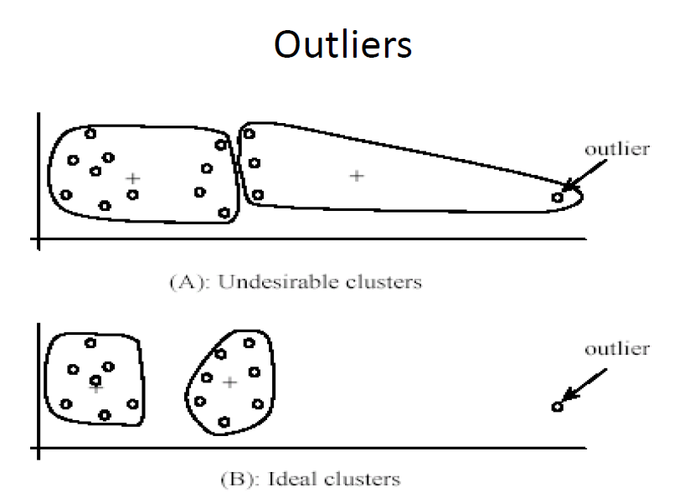

Approaches
Hierarchical
- Find successive clusters using previously established clusters
Partitional
- Centroid

K-means steps
1. Randomly assign each point to a cluster
2a) Compute the cluster centroids – the point at the mean position of all of the cluster points
2b) Assign each point to its nearest centroid
3. Repeat step 2 until ‘convergence’

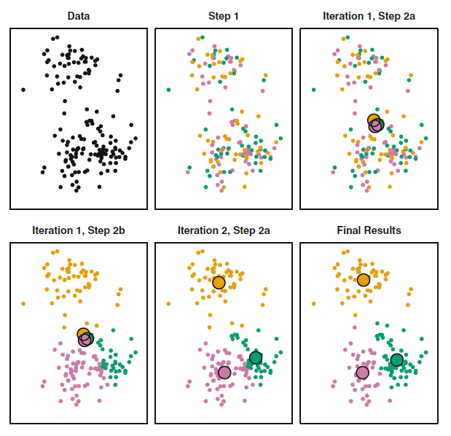

Convergence / stopping criteria
Several options, could be combined?
- # of reassigned data points – threshold or nil
- # of reassigned centroids – threshold or nil
- Threshold in change to SSE

B. Ideas
- Show each step in hierarchical clustering
  - Maybe even with a click to move forward
- Don’t allow outliers
  - Dealing with outliers is a pre-processing step – out of scope
- Could allow the user to seed the initial centroids

C. Requirements
- I think I will need to use OOP for the observations
  - A little more complicated in code, but easier to keep track of states
    - Which cluster?
    - Is it a centroid?
    - I guess I can also store the coordinates in 3 scales: arr_, arr_norm, pixels
      - Perhaps to start I could use a dummy dataset where I don’t need to scale the data.
- Convergence / stopping criteria
  - I think I will just use: “No data point changes cluster”
- Will need a list of colours and markers for the clusters. i.e., need the clusters to be very distinct.
  - Blue, red, grey ?
  - X, +, 0 ?
Below – may be good colours to ‘eyedrop’ – from ‘Intro to Stat Learn”. (Someone’s thought about what 3 distinct colours could be’):
- Blue-Green? (118, 173, 215)
- Orange? (222, 160, 0)
- Grey? (205, 121, 167)
- Green (0, 159, 115)

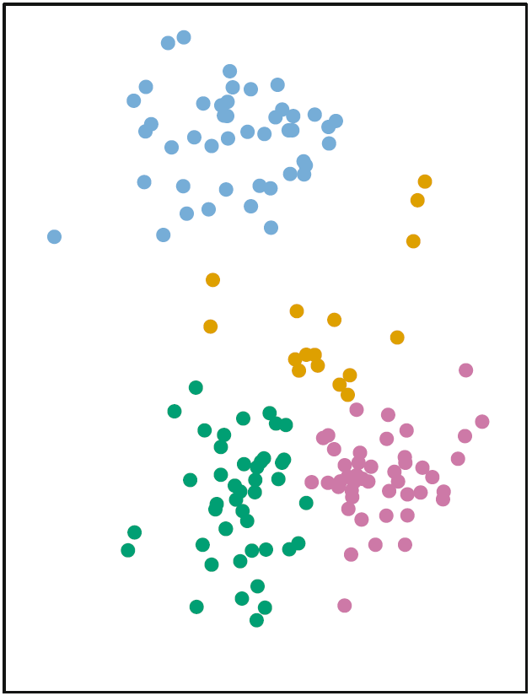

D. Whiteboading my requirements
Translating all the thinking into how I will approach the code
- Build a dataset from scikit ‘blobs’ – should have 3 clusters
  - Maybe 150 data points… seems to be a common number
- Define colour and marker for … 5 clusters
  - Colours = as above, plus bright yellow and red
  - Markers – do I need? Maybe let’s start with just colours
- Build a ‘point’ class
  - Knows its cluster (not, cluster 1 vs cluster 2 is meaningless/arbitrary)
  - Knows whether it is a centroid
  - Draws itself
    - Knows its coordinates in pixels and arr units
    - Access its colour from a set of global colour tuples
    - Draws a much larger radius circle if centroid
- Sub-algorithms
  - Calculate SSE for each cluster
    - Calculate Euclidian distance from centroid
- ‘Algo’ needs to keep track of centroids

- Flags
  - Do I want the algo to all execute at once, or by steps? (clicking)
- Printing on the right
  - Total SSE for all clusters
  - K
- I/O
  - Set K – just do simple with ‘a’ ‘d’ or UP, DOWN
  - 2-5 only

